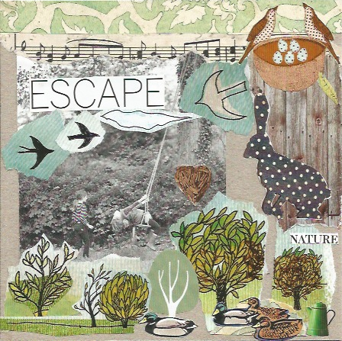

**NCS Summer Holiday ‘Forest school’ sessions. JULY/AUG 2025**

**Wonderful Wild days in ancient private woodland**

**Exciting and fun outdoor adventures exploring and discovering the wonders and secrets of the woodland. Play games, learn practical skills. Practice crafts. Gather round the camp fire circle. Make new friends, be active and have a great time in nature.**

**July Tues 22nd, Weds 23rd, Thurs** **24th**. £37 a session per child 7+yrs. 9.30am-3:0. Under 8’s can attend half day either morning or afternoon with a lunch session.

**July Tues 29th, Weds 30th, Thurs 31st**£37 a session per child 7+yrs. 9.30am-3:0. Under 8’s can attend half day either morning or afternoon with a lunch session.

**August Tues 5th, Weds 6th Thurs 7th.**£37 session per child 7+yrs. 9.30am-3:00pm.

*** Under 7’s can attend half day either morning or afternoon with a lunch session.

Bring a packed lunch, stay all day.

Every day is different.

Book three sessions get a 10% discount.

**Please email or telephone to book. Information and a consent form will be sent to you online thank you..**